Ai Assisted coding Assignment-11.1
Name:Kanneboyina Meghana
B-44
HTNO:2303a52345
Task 1: Stack Implementation
Prompt: Generate a Python Stack class with push, pop, peek, and is_empty methods including docstrings and sample output.
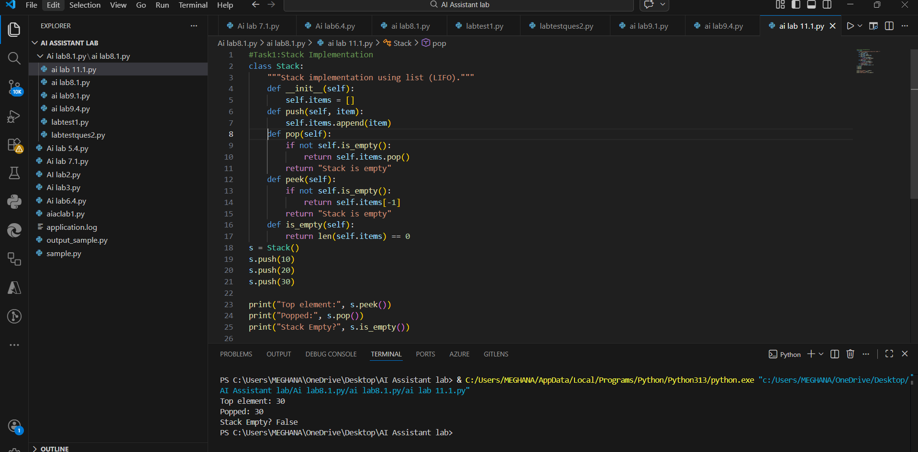
Observation
1.Stack follows LIFO principle.
2.push() adds element to top.
3.pop() removes last inserted element.
4.Implemented using Python list.
Task 2: Queue Implementation
Promtpt: Create a Python class Queue using list to implement FIFO principle. Include methods enqueue(), dequeue(), peek(), and size(). Add docstrings, comments, and example usage with output.
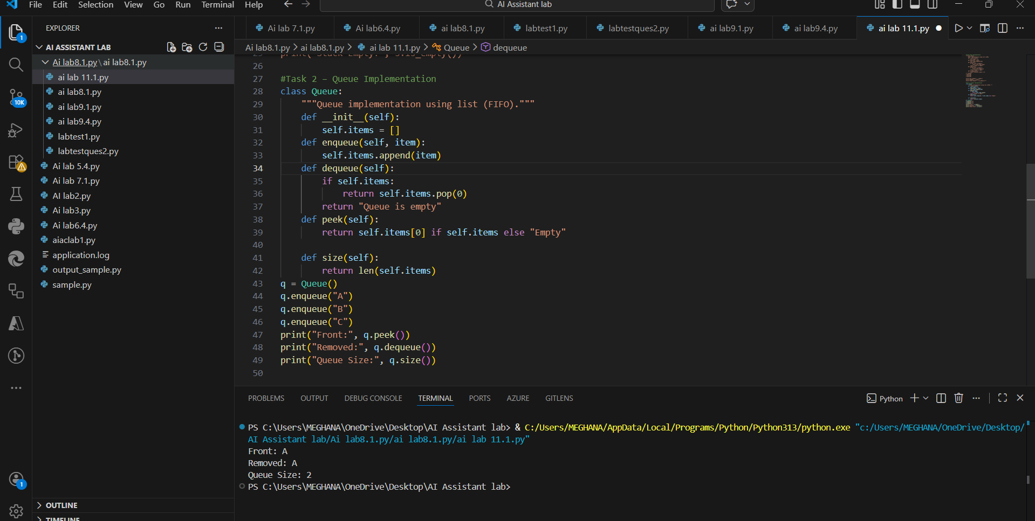
Observation
1.Queue follows FIFO principle.
2.enqueue() inserts at rear.
3.dequeue() removes from front.
4.Suitable for scheduling systems.
Task 3: Linked List
Prompt: Generate a Python implementation of a Singly Linked List with Node and LinkedList classes. Include methods to insert elements at the end and display the list. Provide documentation and sample output.

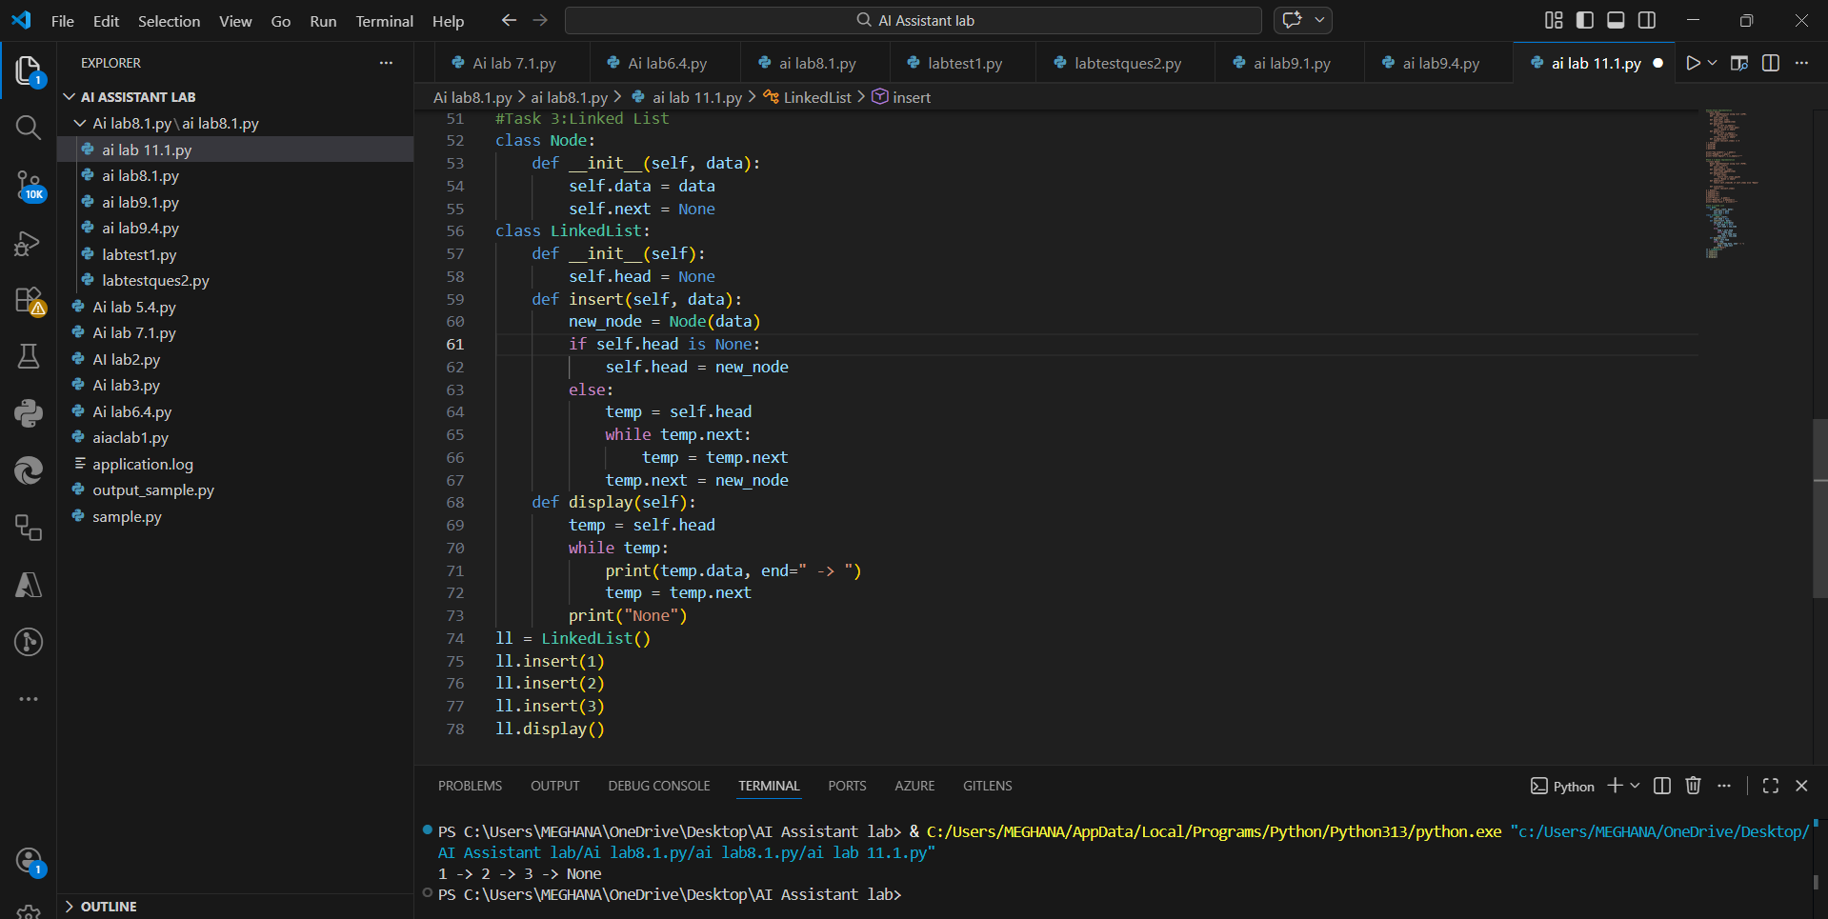
Observation
1.Dynamic memory allocation.
2.No fixed size like arrays.
3.Efficient insertion at end.
Task 4: Binary Search Tree (BST)
Prompt: Develop a Binary Search Tree in Python with recursive insert and inorder traversal methods and demonstration code.
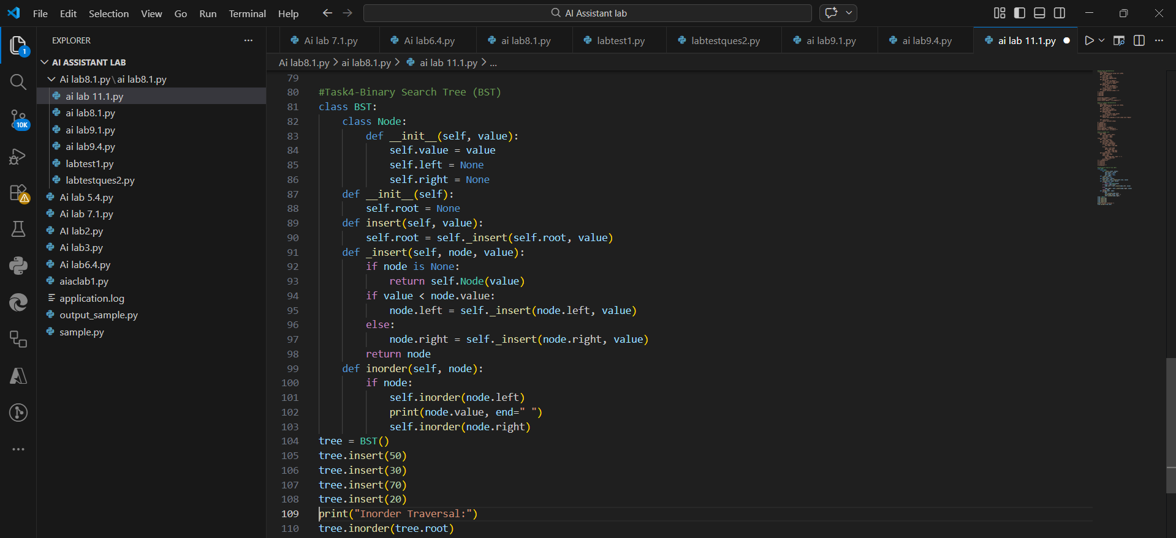
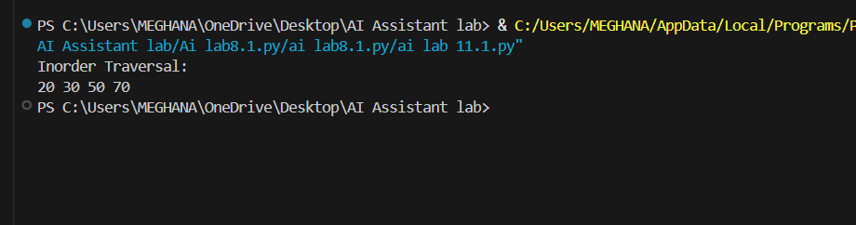
Observation
1.Left child < Parent < Right child.
2.In-order traversal gives sorted output.
3.Efficient searching (O(log n) average).
Task 5:
Prompt: Implement a Hash Table in Python with chaining for collision handling and methods insert, search, and delete.
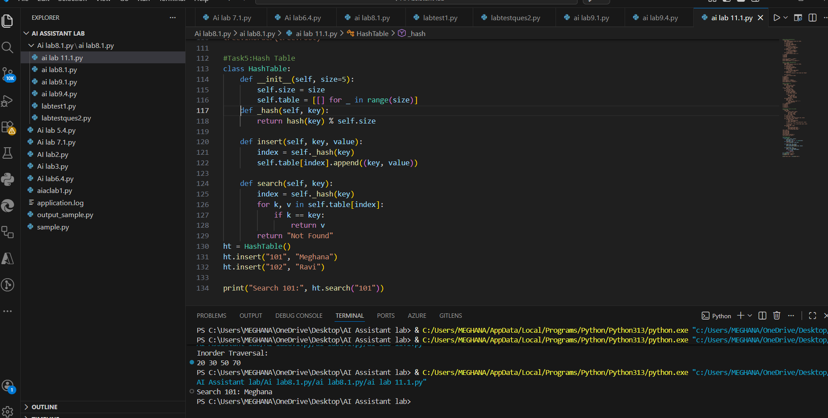
Observation
1.Provides O(1) average search time.
2.Collision handled using chaining.
3.Used in databases & dictionaries.
Task 6 – Graph Representation
Promtpt: Generate a Python Graph class using adjacency list representation. Include methods add_vertex(), add_edge(), and display(). Provide sample execution and output.

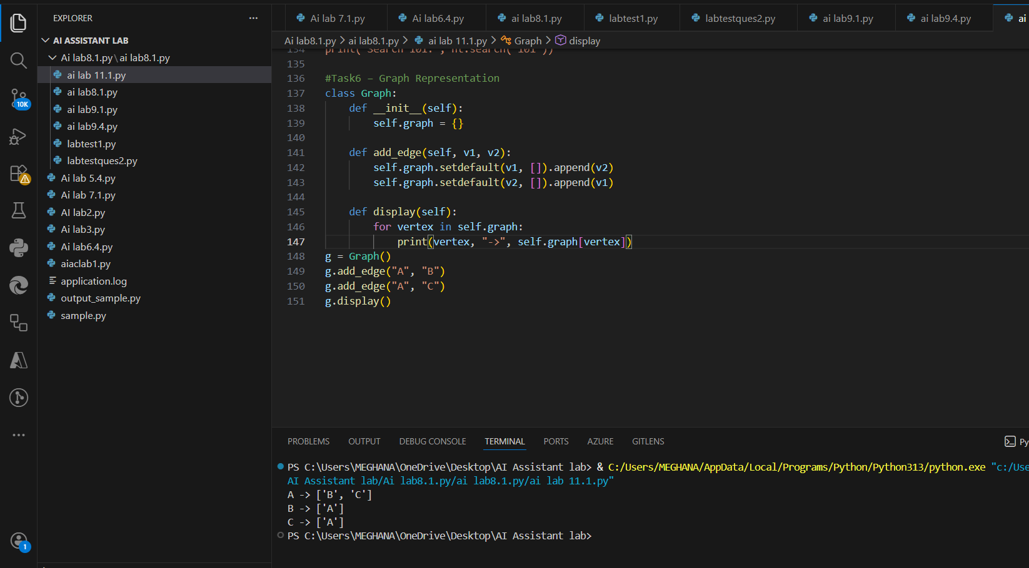
Observation
1.Represents real-world networks.
2.Uses adjacency list.
3.Efficient for sparse graphs.
Task 7 – Priority Queue
Implement a Priority Queue in Python using the heapq module. Include methods enqueue(priority, item), dequeue(), and display(). Add comments and example output.
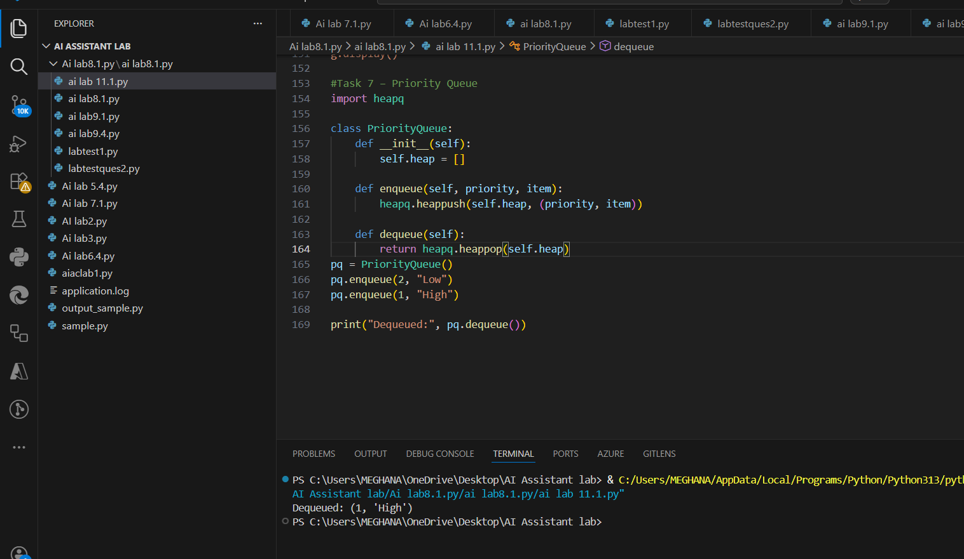
Observation
1.Based on heap.
2.Smallest priority served first.
3.Used in scheduling & OS.
Task 8:Deque
Prompt: Create a Deque in Python using collections.deque with insert and remove operations from both ends.
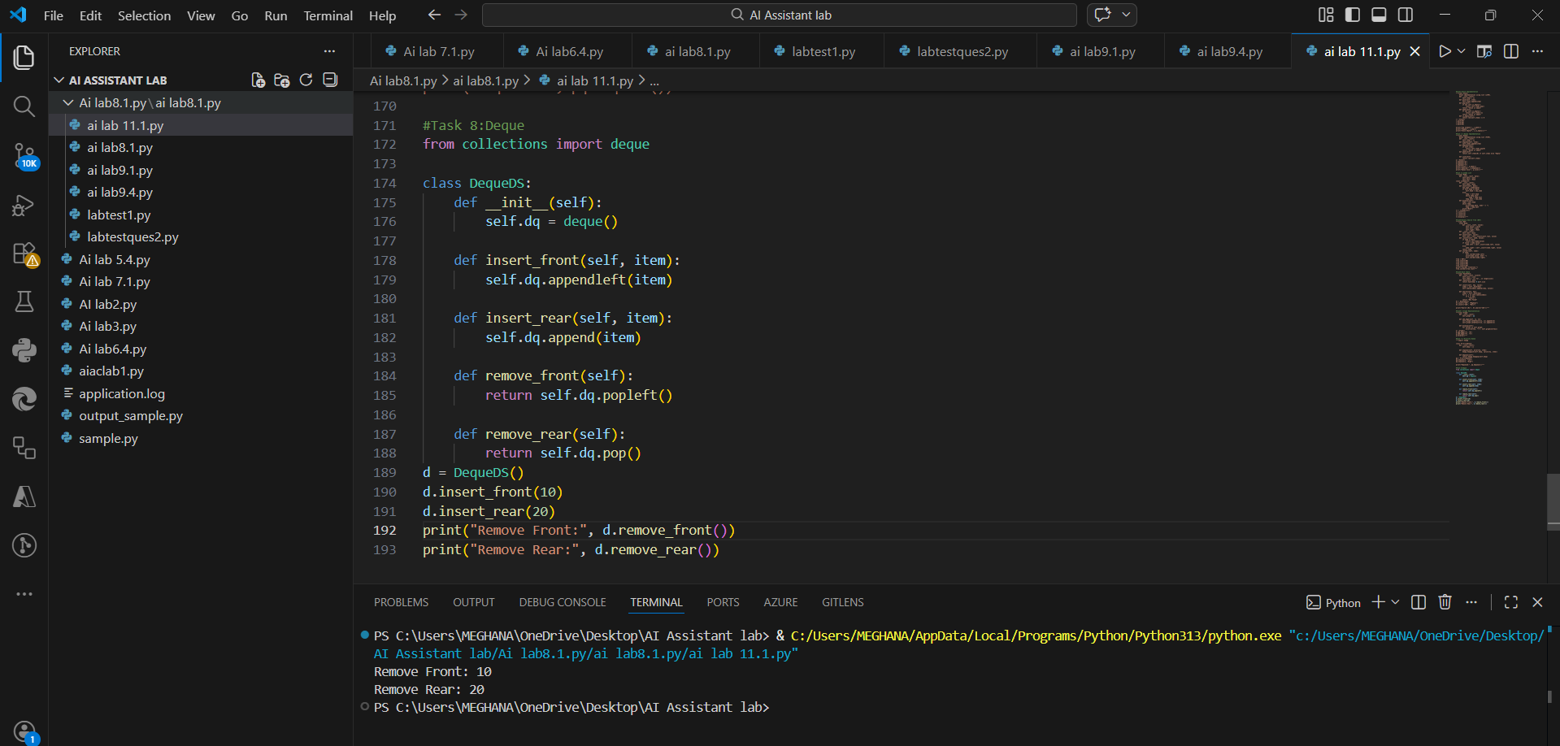
Observation
1.Double-ended operations allowed.
2.Faster than list for front operations.
3.Used in sliding window algorithms.
Task 9: Campus System
Prompt:Select appropriate data structures for campus management features, justify choices, and implement one feature in Python.
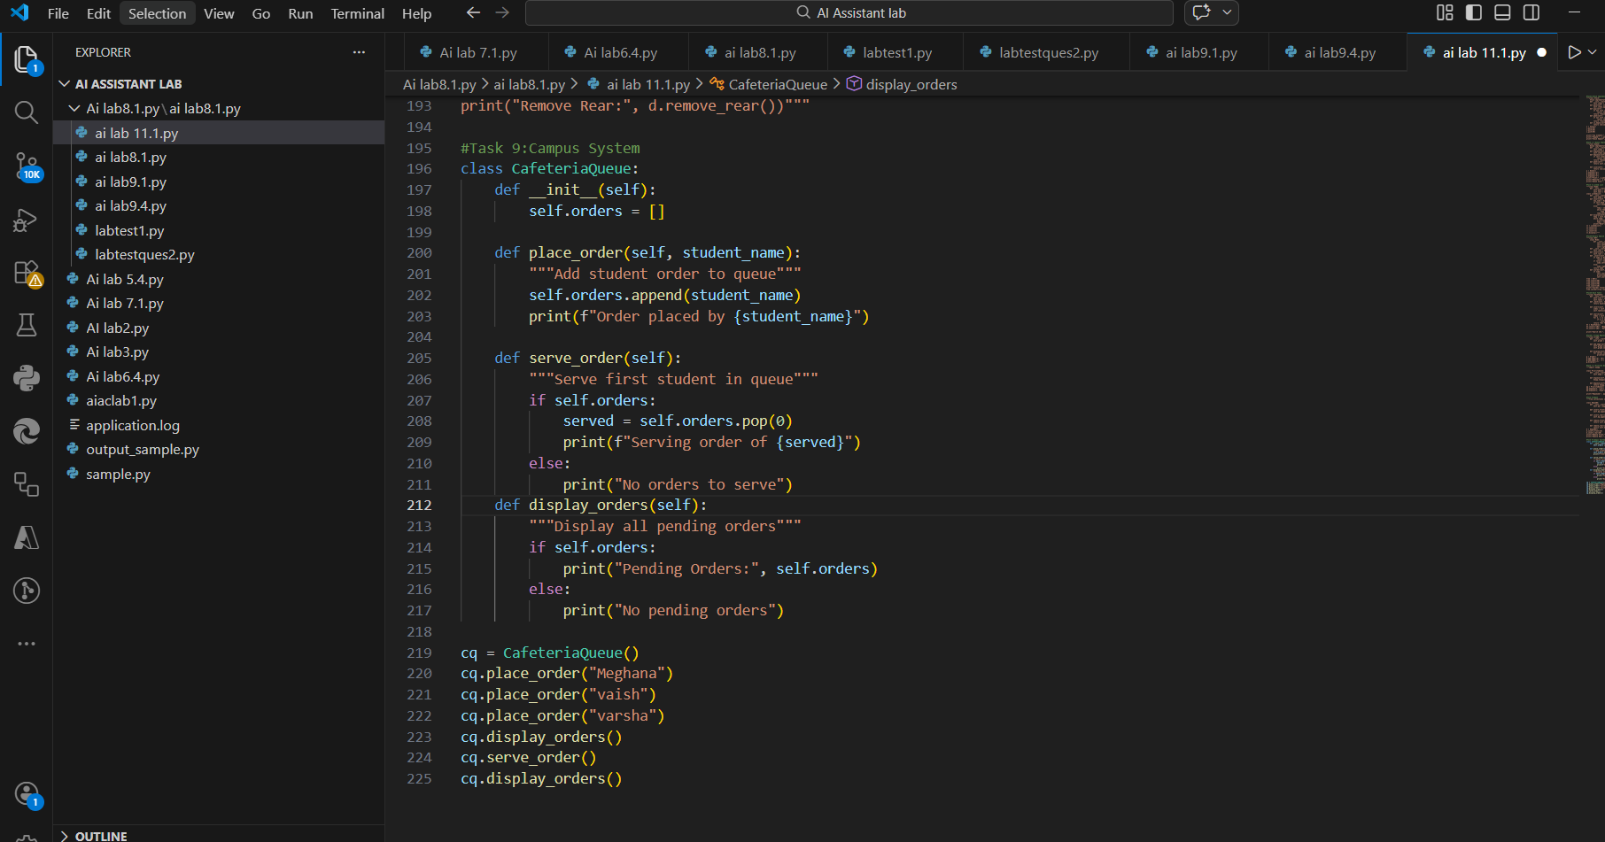
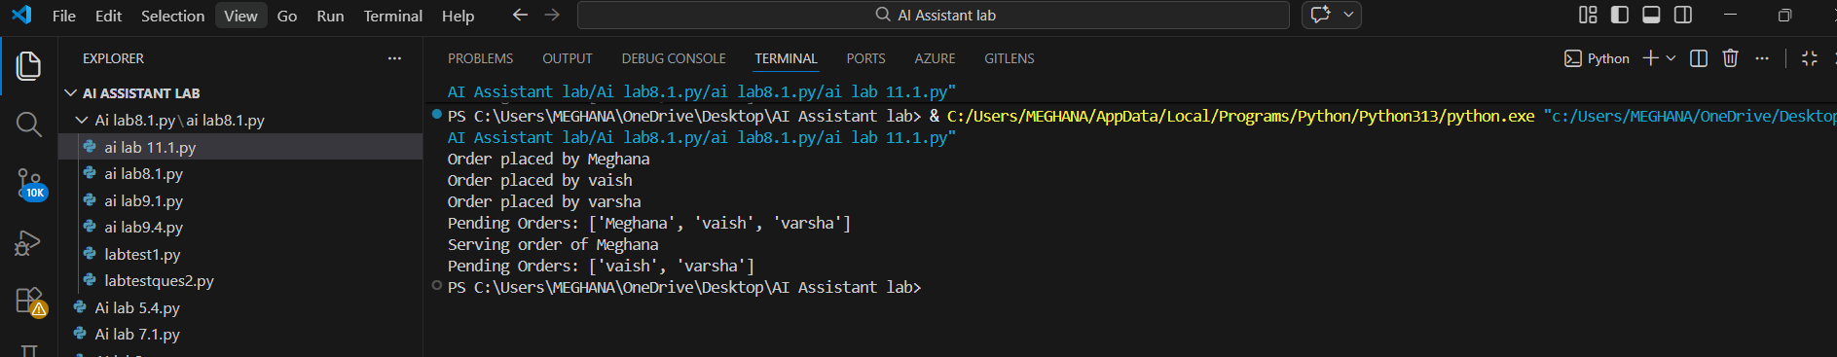
Observation:
1.Queue data structure is suitable for cafeteria order management because it follows the FIFO principle.
2.Students are served in the same order they place their orders.
3.This structure ensures fairness and systematic processing.
4.The implementation demonstrates real-world application of queues.
Task 10: Smart E-Commerce Platform
Choose suitable data structures for e-commerce features, justify selections, and implement one feature in Python.
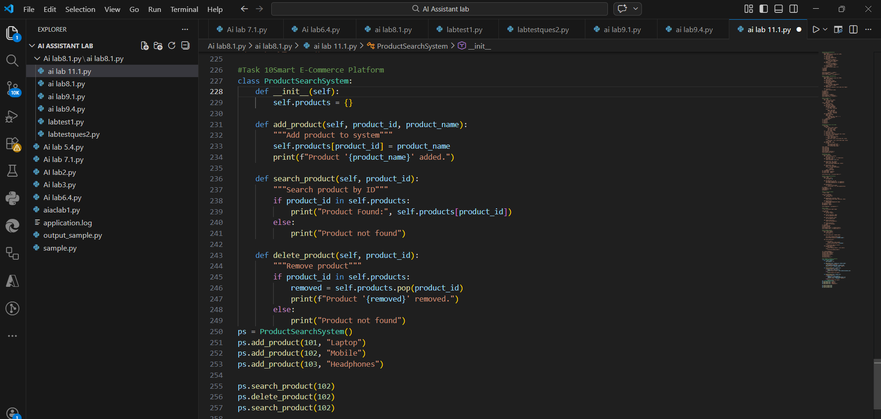
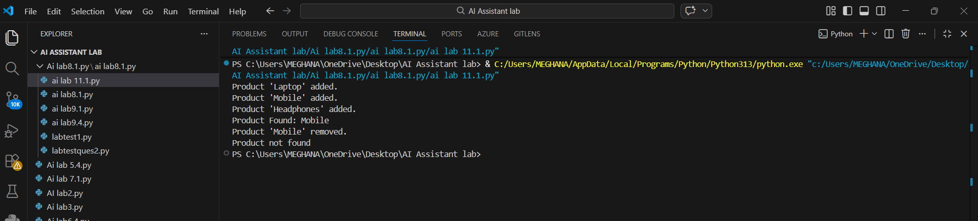
Observation:
1.Hash Table is ideal for product search because it provides fast lookup using product ID.
2.Searching, insertion, and deletion operations are efficient (average O(1)).
3.This structure improves performance in large-scale e-commerce systems.
4.The implementation shows how data structures optimize real-time applications.

